1. Agenda:
   1. If we shutdown a microservice gracefully, how it deregisters itself with Eureka Server?
   2. How Eureka Microservice reacts to it?
2. 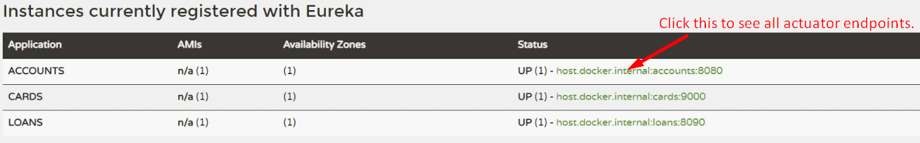
3. 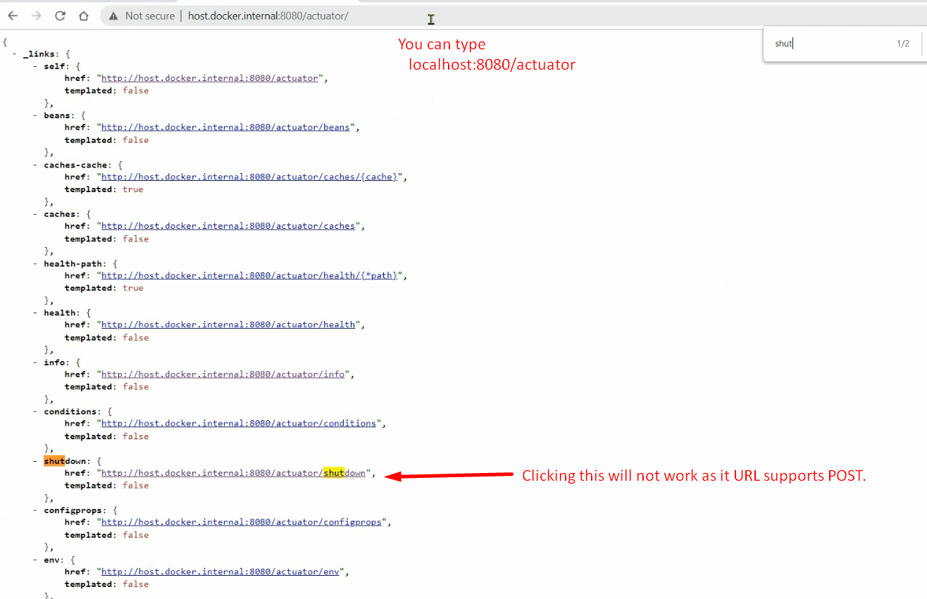
4. 
5. 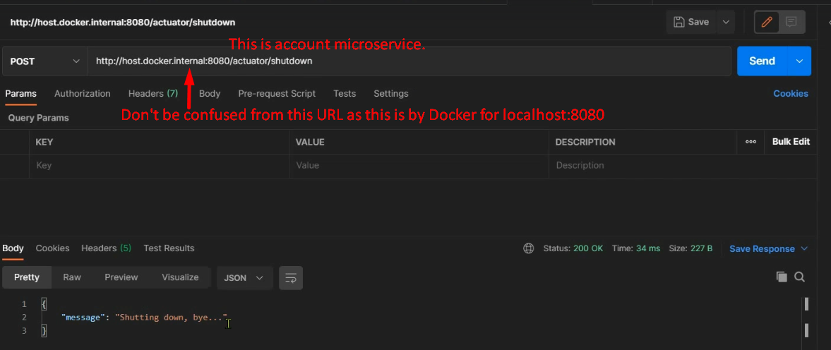
6. 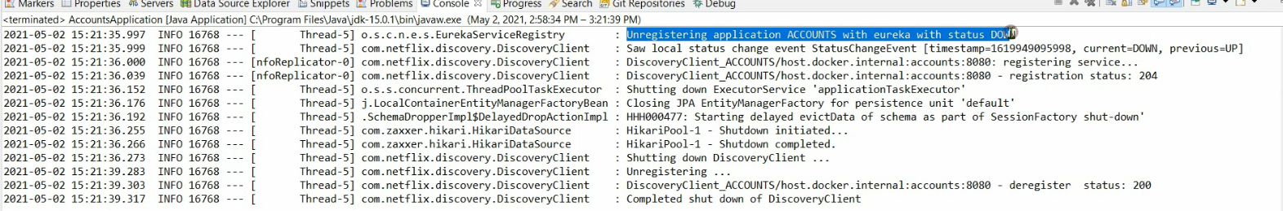
7. 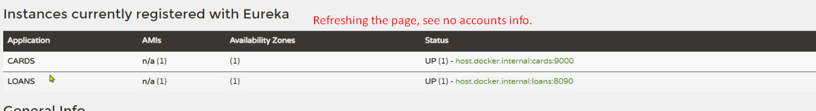
8. **Question**: What if forcefully terminate an instance?
9. **Answer**: We know Eureka will wait for heartbeat from the instance for 3 times with 30 seconds interval. So till 90 seconds, it doesn’t receive any heartbeat, Eureka Server will deregister the instance’s details.